**1. Create Newsroom page component using base page component.**

Component Path: /apps/training/components/newsroompage

**newsroompage.html**

<sly data-sly-use.page="training.components.basepage"></sly>

<div class="newsroom-container">

<sly data-sly-resource="${'news' @ resourceType='training/components/news'}"></sly>

</div>

**.content.xml**

<jcr:root xmlns:jcr="http://www.jcp.org/jcr/1.0"

xmlns:cq="http://www.day.com/jcr/cq/1.0"

jcr:primaryType="cq:Component"

jcr:title="Newsroom Page"

componentGroup="Training Components"

sling:resourceSuperType="training/components/basepage"/>

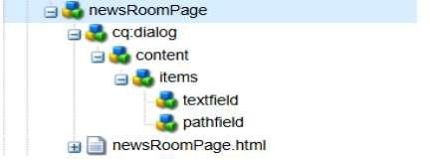

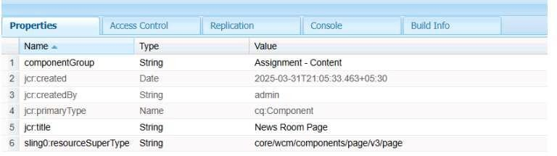

**2. Create custom page properties as NEWS configurations, where I can author the default news image. Read More CTA for News Article.**

**dialog.xml**

<jcr:root xmlns:jcr="http://www.jcp.org/jcr/1.0"

xmlns:sling="http://sling.apache.org/jcr/sling/1.0"

xmlns:cq="http://www.day.com/jcr/cq/1.0"

jcr:primaryType="cq:Dialog"

cq:dialogMode="floating">

<content jcr:primaryType="nt:unstructured">

<items jcr:primaryType="nt:unstructured">

<newsImage

jcr:primaryType="nt:unstructured"

sling:resourceType="granite/ui/components/coral/foundation/form/fileupload"

fieldLabel="Default News Image"

name="./newsImage"

allowUpload="true"/>

<readMoreCTA

jcr:primaryType="nt:unstructured"

sling:resourceType="granite/ui/components/coral/foundation/form/textfield"

fieldLabel="Read More"

name="./readMoreCTA"/>

</items>

</content>

</jcr:root>

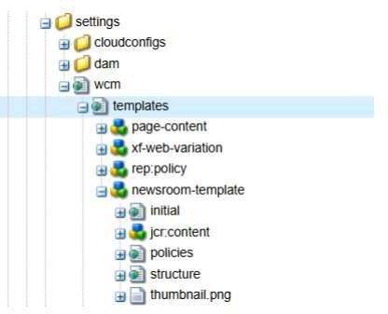

**3. Create Newsroom template type by using newsroom page component.**

Component Path: /conf/training/settings/wcm/template-types/newsroom

**.template-type**

<jcr:root xmlns:jcr="http://www.jcp.org/jcr/1.0"

xmlns:cq="http://www.day.com/jcr/cq/1.0"

jcr:primaryType="cq:TemplateType"

jcr:title="Newsroom Template Type"

componentGroup="Training Components"

jcr:description="Template type for newsroom pages"

allowedPaths="[/content/training(/.*)?]"

allowedChildren="*"

sling:resourceType="training/components/newsroompage"/>

**structure/jcr:content/.content.xml**

<jcr:root xmlns:jcr="http://www.jcp.org/jcr/1.0"

jcr:primaryType="nt:unstructured"

sling:resourceType="training/components/newsroompage"/>

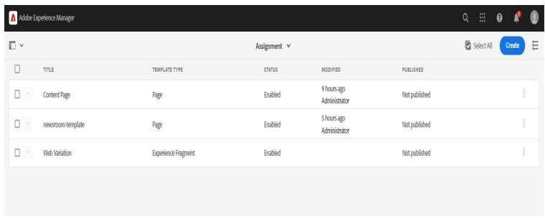

**4. Create Newsroom Template using newsroom template type.**

Component Path: /conf/training/settings/wcm/templates/newsroom

**.template**

<jcr:root xmlns:jcr="http://www.jcp.org/jcr/1.0"

xmlns:cq="http://www.day.com/jcr/cq/1.0"

jcr:primaryType="cq:Template"

cq:templateType="/conf/training/settings/wcm/template-types/newsroom"

jcr:title="Newsroom Template"

allowedPaths="[/content/training(/.*)?]"

allowedChildren="*"/>

**structure/jcr:content/.content.xml**

<jcr:root xmlns:jcr="http://www.jcp.org/jcr/1.0"

jcr:primaryType="nt:unstructured"

sling:resourceType="training/components/newsroompage"/>

**policies/.content.xml**

<jcr:root xmlns:jcr="http://www.jcp.org/jcr/1.0"

jcr:primaryType="nt:unstructured"

cq:policy="training/components/newsroompage"/>

**5. Apply the styling to the news/ hello world component from the ui.frontend folder. Additionally, you can create a custom style to apply the above styling to the Hello World or the news component.**

Component Path: /apps/training/ui.frontend/src/main/webpack/site/css

**news.css**

.news-component h2 {

color: green;

font-size: 24px;

}

.news-component p {

color: yellow;

font-size: 16px;

}

.news-component .date {

color: black;

font-size: 14px;

}

.hello-world {

color: blue;

font-size: 20px;

}

**hello-world.css**

.hello-world {

color: red;

font-size: 18px;

}

**clientlib-news**

<jcr:root xmlns:jcr="http://www.jcp.org/jcr/1.0"

xmlns:cq="http://www.day.com/jcr/cq/1.0"

jcr:primaryType="cq:ClientLibraryFolder"

categories="[training.news]"

dependencies="[training.base]"

css="[news.css, hello-world.css]"/>

Add the client library reference in the base page component.

<link rel="stylesheet" href="/etc.clientlibs/training.news.css" type="text/css">

